Gross profit margin
- The average gross profit on each dollar of sales before operating expenses:
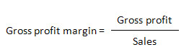
- It will depend on the industry you’re in, so it’s important to measure yourself against industry benchmarks
- It is an excellent way of assessing the profitability of each product

Net profit margin
- The percentage profit your business makes for every dollar of revenue:
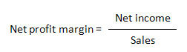
- It tells you whether you’re making a profit after covering all your costs
- It will be partly determined by your industry – some retailers run high-volume, low-margin businesses, others sell a few expensive items with plenty of margin built in

Current ratio
- Helps measure the solvency of your business by comparing current assets (like unpaid invoices) to current liabilities (unpaid bills):
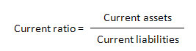
- Ideally, your current ratio should be two or more, which means your assets are at least double your liabilities
- If sales are growing and you have a short operating cycle, a lower number may be fine
- If you have a long operating cycle, you may want a higher current ratio to make sure liabilities don’t get out of control

Return on owner’s equity
- Compares your net business income to the equity you’ve invested in the business
- It reveals how much you’re making from your investment:
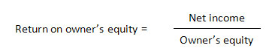
- For example, if you’ve invested $200,000 and the business is generating a net income of $100,000 a year, your return on owner’s equity is 50 per cent
- It tends to increase over time as the business grows, especially if your personal investment remains the same
- It’s a useful way to compare what you’ve earned from your business to what you may have earned from another investment

